
 | ASSIGNMENT 3
Subject : | System Analysis and Design (SECP2613)
Session : | 2023/2024 Semester 2
Task : | REPORT on INDUSTRY TALK
Title : | Project Management
Duration : | 2 May 2024 Week 7
Submission : | Submit softcopy (in .pdf format) via e-learning
Instructions: : | - 3 ~ 4 students per group  - All answers should be printed on and uploaded via link specified in e-learning.  - Any plagiarism – copying directly from other groups will result in both groups will be penalized by getting an ‘F’ grade.
Poster for Industry Talk

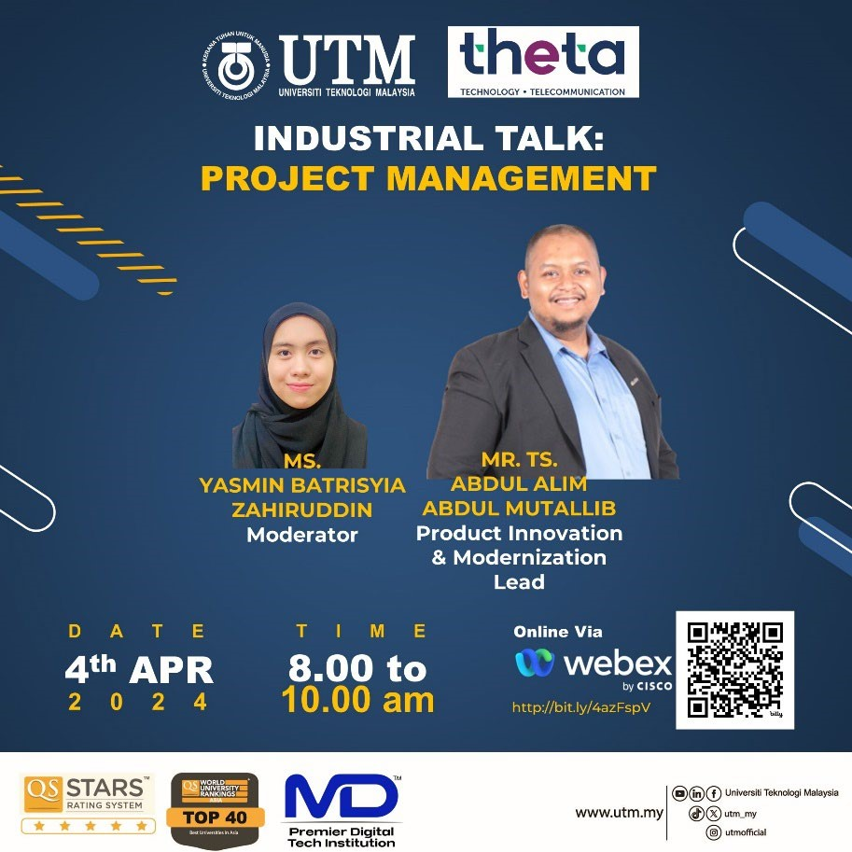

Instruction:
- Students are required to prepare A REPORT.

- The length of the REPORT SHOULD NOT EXCEED 3 PAGES:
  - Page one: This is the cover of the REPORT; it should include a proper title and a representative picture. The cover page should also include the titles for the topics covered in the REPORT and names of group member.
  - Pages two and three should include:
- Industry Talk [4th April 2024] Project Management. The content should consist of: description of the project management experienced by the speaker. - The reflection [each student] from the talk.
**Note: The content of your report is your own opinion and views. You may refer the rubric of report in the next page.

- The report will contribute 10% of the course assessment.

- Follow the format of report as follows:
  - Justify alignment for text description.
  - Include the date in each page.
  - Design your report using your own creativity.

- You may refer to the following links as your reference for designing your REPORT:
  - https://www.flipsnack.com/templates/
  - https://design.tutsplus.com/t/tutorials/search/report+template
  - https://dribbble.com/tags/report-template

- PLAGIARISM of the content is prohibited. If any of the content is known to be copied from other website/review/blogs, you will be given 0 mark.

- You can get photos/information from other resources, but you must include credits (in citation/link) to the original owners.

Rubric for Report (10%)

Criteria | Excellent 10-7 | Fair 6-4 |  | Poor 3-0 | WEIGHTAGE | MARKS
Informative and Attractive | - Provide accurate information (Content).  - All required information is presented in a logical order. | - Some information (Content) is inaccurate, but presented in a logical order.  - Very few required information is missing and presented in a logical order. |  | - Most Information (Content) are inaccurate, or not presented in a logical order, making  it difficult to follow.  - Most required information is missing and not presented in a logical order, making  it difficult to follow. | 10 | X 10  10
Contents | Page one:  This is the cover of the REPORT; it should include a proper title and a representative picture. The cover page should also include the titles for the topics covered in the REPORT and names of group member.  Pages two and three should include:  Industrial Talk [4th April 2024] Project Management.  The content should consist of: description of the project management experienced by the speaker.  The reflection [each student] from the talk. |  |  |  | 30 | X 30  10
 | - All contents included  - Very good presentation of content and well organized.  - Use many graphics, pictures. | - Included but not well covered  - Moderate presentation of content and well organized  - Use moderate graphics, pictures. |  | - Included but poorly covered  - Lack of content and not organized properly.  - Use  inappropriate graphics or pictures.
Reflection | The reflection [each student] from the talk. |  |  |  | 30 | X 30  10
 | Excellent explanation. | Fair explanation. | Poor explanation.
Criteria | Excellent 10-7 | Fair 6-4 |  | Poor 3-0 | WEIGHTAGE | MARKS
Report Features | - Include all required features, such as main report, graphics with captions and reporters.  - All features relate to the subject and are appropriate for the targeted audience.  - The layout is creative. | - Not all required features, such as main report, graphics with captions and reporters.  - All features are almost related to the subject and are appropriate for the targeted audience.  - The layout shows some degree of  creativity but is not organized logically and/or is cluttered. |  | - Lack of features, such as main report, graphics with captions and reporters.  - All features are unrelated to the subject and are inappropriate for the targeted audience.  - The layout is messy, disorganized or cluttered. | 10 | 10 | X 10
Organization and Structure |  Structure of text is  interesting and organized very well, easy to understand. |  Structure of text is quite interesting and organized. |  |  Most parts of the structure of text are not really interesting and unorganized. | 10 | 10 | X 10
Text | - All texts are easy to read and clear explanation.  - Use  appropriate font size.  - Use not more than three different font styles. | - Most texts are easy to read and clear explanation.  - Use  appropriate font size.  - Use more than three different font styles. |  | - Some texts are difficult to read unclear explanation.  - Use medium font size.  - Use more than four different font styles. | 5 | 10 | X 5
Timeliness |  Due date on time submission. |  Due date one day late submission. |  |  Due date more than one day late submission. | 5 | 10 | X 5
Total |  |  |  |  |  |  | / 100

